Bangladesh Medical Association (BMA)
List of Life Member-26
51. BMA Panchagarh Branch

Sl No | Voter No | Voter Details
1 | Voter No  LM-5100001 | DR. ABU. MD. AHSAN FIROZ  F/Name: Late. Abu Md. Habib  M/Name: Mrs. Hasina Begum  BM & DC Reg. No: 33024  NID:  Cell: 01716251751  Address: Vill: Kayet Para, Post: Panchagarh, Upazilla: Panchagarh Sadar, Dist: Panchagarh  Blood Group: B+
2 | Voter No  LM-5100002  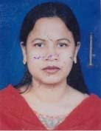 | DR. NASRIN JAHAN  F/Name: Md. Tohidul Islam  M/Name: Mrs. Rabeya Begum  BM & DC Reg. No: 37341  NID:  Cell: 01919010707  Address: Vill: Kayet Para, Post: Panchagarh, Upazilla: Panchagarh Sadar, Dist: Panchagarh  Blood Group: O+
3 | Voter No  LM-5100003  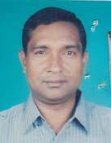 | DR. A.F.M NURULLAH  F/Name: Md. Ibrahim  M/Name: Most. Majeda Begum  BM & DC Reg. No: 20136  NID: 7727304115635  Cell: 01718613484  Address: Jalashi Para, Panchagarh Pouroshova, P.O: Panchagarh, Thana+Dist: Panchagarh  Blood Group: A+
4 | Voter No  LM-5100004  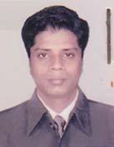 | DR. MD. MONSUR ALAM  F/Name: Md. Foyzul Islam  M/Name: Mst. Noima Khatun  BM & DC Reg. No: 28236  NID: 7727301103344  Cell: 01726315683  Address: EMO, Sadar Hospital, Panchagarh  Blood Group: O+
5 | Voter No  LM-5100005  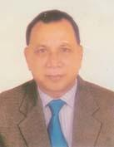 | DR. MUHAMMAD NURUL ISLAM  F/Name: Late. Md. Mafijuddin Prodhan  M/Name: Late. Mrs. Nurjahan Begum Prodhan  BM & DC Reg. No: 7315  NID: 7712594432865  Cell: 01716554638  Address: 315/C, Khilgaon, Dhaka  Blood Group: O+
6 | Voter No  LM-5100006 | DR. MD. SIDDIQUR RAHMAN  F/Name: Late. Pobaruddin Ahmed  M/Name: Mst. Nurun Nahar  BM & DC Reg. No: 14119  NID: 7727302106625  Cell: 01714383649  Address: UHFPO, Upazilla Debiganj, Panchagarh  Blood Group: A+
7 | Voter No  LM-5100007  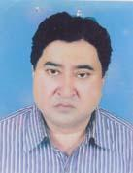 | DR. MOWIA BAKSH CHAUDHURY  F/Name: Late. Kasim Baksh Chaudhury  M/Name: Mst. Nurun Nahar  BM & DC Reg. No: 17492  NID:  Cell: 01712521459  Address: UH & FPO, U H C Atowary, Panchagarh  Blood Group: A+
8 | Voter No  LM-5100008 | DR. K.M ARIFUR RAHMAN  F/Name: K.M Abul Hashem  M/Name: Mrs. Laily Begum  BM & DC Reg. No: 43905  NID: 7727309110284  Cell: 01740612517  Address: Sadar Hospital Quarter, Panchagarh  Blood Group: A+
9 | Voter No  LM-5100009  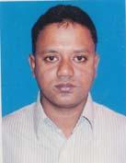 | DR. MD. ABUL KASHEM  F/Name: Md. Abdul Hai  M/Name: Mst. Sahera Khatun  BM & DC Reg. No: 44203  NID: 7528701107649  Cell: 01718659095  Address: Hospital Quarter, Sadar Hospital, Panchagarh  Blood Group: O+
10 | Voter No  LM-5100010 | DR. AUDHINDRA NATH SARKER  F/Name: Late. Dhirendra Nath Sarker  M/Name: Lima Rani Sarker  BM & DC Reg. No: 17689  NID: 8524902019883  Cell: 01715426944  Address: Maternal And Child Welfar Centre, Sadar, Panchagarh  Blood Group: A+
11 | Voter No  LM-5100011  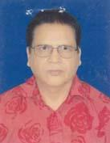 | DR. MD. MAZED ALI MIAH  F/Name: Late. Md. Muzibur Rahman Miah  M/Name: Late. Rokeya Begum  BM & DC Reg. No: 21360  NID: 9329516321840  Cell: 01712603103  Address: MCWC, Panchagarh Sadar  Blood Group: A+
12 | Voter No  LM-5100012  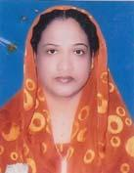 | DR. AFRUZA BEGUM  F/Name: Kazi Abdul Latif  M/Name: Rabeya Khatun  BM & DC Reg. No: 27384  NID: 7727308126887  Cell: 01717136606  Address: Village: Puratun Panchagarh, P.O: Dhakkamara, Dist: Panchagarh  Blood Group: O+
13 | Voter No  LM-5100013  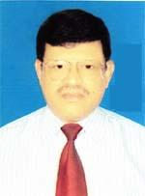 | DR. MD. MOSHARRAF HOSSAIN  F/Name: Late. Md. Bajlar Rahman  M/Name: Mosa. Kadija Khatun  BM & DC Reg. No: 12886  NID:  Cell: 01712084339  Address: Senior Consultant Medicine, Adhunik Sadar Hospital panchagarh  Blood Group: O+
14 | Voter No  LM-5100014 | DR. MD. AMIR HOSSAIN  F/Name: Late Tofiz Uddin Ahmed  M/Name: Gomeron Nessa  BM & DC Reg. No: 27067  NID: 2696352220411  Cell: 01711316199  Address: Panchagarh Sadar Panchagarh  Blood Group: O+
15 | Voter No  LM-5100015  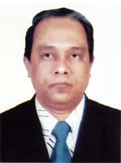 | DR. MD. FERDOUS KAMAL  F/Name: Late Mohammad Fazlul Haque  M/Name: Mrs. Firoza Begum  BM & DC Reg. No: 24782  NID: 19692726401000011  Cell: 01717849594  Address: Panchargarh Diabetic Hospital, Panchargarh  Blood Group: O+
16 | Voter No  LM-5100016  No Image | NILL  F/Name:  M/Name:  BM & DC Reg. No:  NID:  Cell:  Address:  Blood Group:
17 | Voter No  LM-5100017  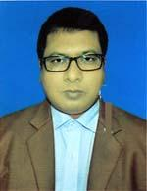 | DR. S.I.M RAZIUL KARIM  F/Name: Md. Abdur Rouf  M/Name: Most. Shaheda Banu  BM & DC Reg. No: 32328  NID: 7727309130611  Cell: 01717525946  Address: Hospital Quater Sadar Hospital, Panchagarh  Blood Group: B+
18 | Voter No  LM-5100018  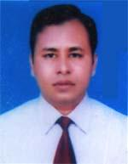 | DR. MD. MONOWARUL ISLAM  F/Name: SHAMS UDDIN  M/Name: Raisun Nahar  BM & DC Reg. No: 30371  NID: 2695047980213  Cell: 01712931750  Address: Sadar Hospital, Panchagarh  Blood Group: O+
19 | Voter No  LM-5100019  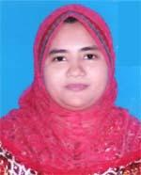 | DR. AFIFA ZINNAT AFI  F/Name: Dr. Ashraf Uddin Ahmed  M/Name: Anjuman Ara Ahmed  BM & DC Reg. No: 52922  NID: 2695047980214  Cell: 01717402113  Address: Adarsha Clinic, 1st Floor, Mithapukur, Panchagarh  Blood Group: O+
20 | Voter No  LM-5100020  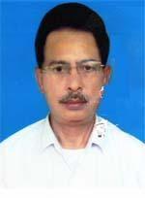 | DR. MOSADDEQUE HOSSAIN  F/Name: Mofazzal Hossain  M/Name: Momena Hossain  BM & DC Reg. No: 13420  NID: 2695045905583  Cell: 01912665825  Address: Vill: Shaltipara, PO: Jagdal, PO & Dist: Panchagarh  Blood Group:
21 | Voter No  LM-5100021  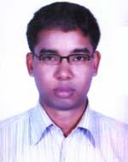 | DR. SUMON CHANDRA ROY  F/Name: Dinesh Chandra Roy  M/Name: Debjani Barmani  BM & DC Reg. No: 55549  NID:  Cell: 01717670931  Address: UPAZILLA HEALTH COMPLEX, TETULIA, PANCHAGARH  Blood Group: A+
22 | Voter No  LM-5100022 | DR. MD. MASUD ALAM  F/Name: Md. Abdul Mannan  M/Name: Mst. Morjina Begum  BM & DC Reg. No: 56351  NID: 8524901006722  Cell: 01717109927  Address: CIVIL SURGEON OFFICE, PANCHAGARH  Blood Group: B+
23 | Voter No  LM-5100023  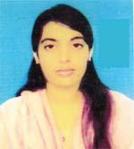 | DR. ZAKIA YASMIN  F/Name: Ezazul Haque  M/Name: Feroza Haque  BM & DC Reg. No: 66240  NID:  Cell: 01717210705  Address: MEDICAL OFFICER, DIABETIC HOSPITAL, PANCHAGARH  Blood Group: B+
24 | Voter No  LM-5100024  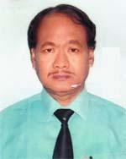 | DR. PITAMBAR ROY  F/Name: Late. Dwaraka Nath Roy  M/Name: Late. Giribala Debi  BM & DC Reg. No: 23283  NID: 7311566863509  Cell: 01715123230  Address: Civil Surgeon, Panchagarh  Blood Group: A+
25 | Voter No  LM-5100025  No Image | DR. MD. ABU ELIAS PRODHAN  F/Name: Md. Taslim Uddin Ahmed  M/Name: Zohra Khatun  BM & DC Reg. No: 9207  NID:  Cell:  Address: New Popular Diagnostic & Sonolab  Thanapra, Boda, Panchagar.  Blood Group: A+
26 | Voter No  LM-5100026  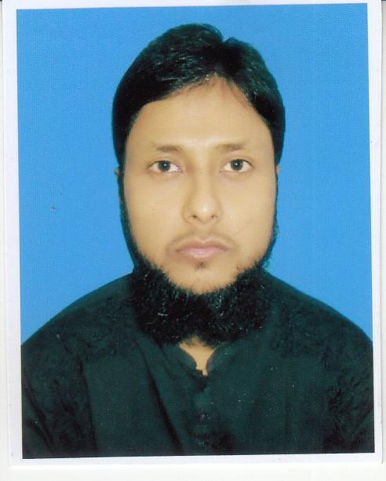 | DR. MD. FAZLE HASAN SIDDIQUI  F/Name: Md. Siddiqur Rahman  M/Name: Mst. Ferdousy Rahman  BM & DC Reg. No: 62691  NID: 3715680751  Cell: 01718695479  Address: Panchagar Diabetic Somiti & Mokbular Rahman Diabetic Hospital, Panchagar.  Blood Group: A+

